Global Geoparks Network (GGN) of UNESCO
-- Geoparks Annual Report 2018

1. Identity of the Geopark: Xingwen UNESCO Global Geopark (China, Asia Pacific Network)
Year of accession: 2005; Year of latest reassessment: 2017
The most important photographs of activities: visits and exchanges among sister geoparks, science popularization tours of geology, science popularization and research tours of geology, etc.
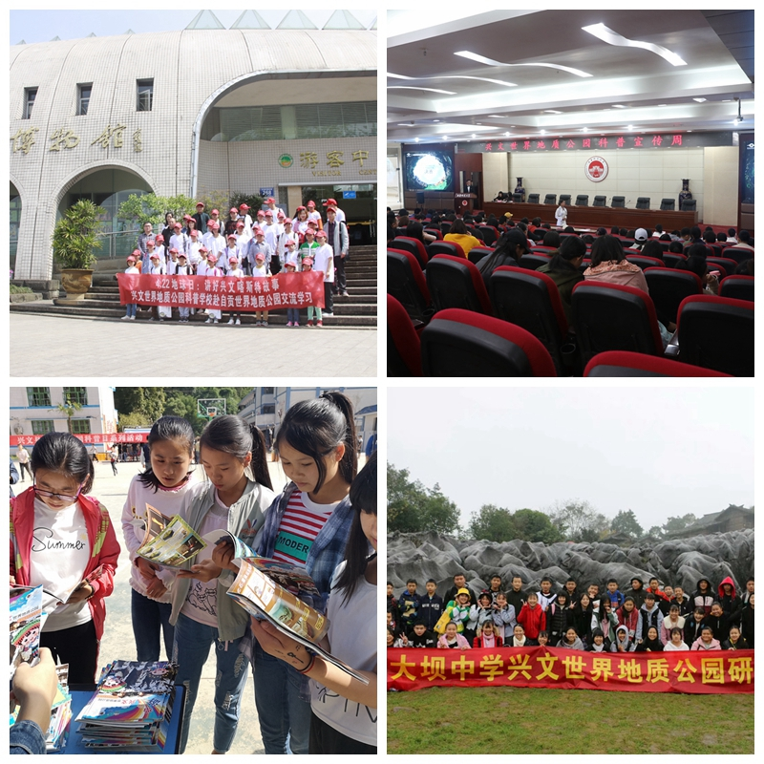
2. Data of the Geopark
It has 273 employees, including a geoscientist, and has received 583,600 visits.
Number of activities: 7 science popularization activities, 1 scientific research project, compiled 1 book of science popularization for children.
Number of schools carrying out the Geopark Education Program: Five schools including Heping Primary School in Xingwen County of Sichuan Province and China West Normal University in Sichuan Province have carried out science popularization tours of geology.
Number of press releases issued by the Geopark: 3 articles on GGN website, 40 articles in English and Chinese on Xingwen UNESCO Global Geopark website, 1 article on TV, 5 articles on newspapers, and more than 260,000 articles on QQ, WeChat and other online media.
Activities of the Geopark
Major achievements: It has strengthened the protection of geological relics, expanded the way of science popularization and education, actively participated in network activities, promoted the sustainable development of geological tourism, and maintained stable financial revenue and expenditure.
Its contribution to GGN -- participating in or organizing network activities: In June, it participated in the Sister Geoparks Action Plan Activity held by the Danxiashan UNESCO Global Geopark. In August, it participated in the UNESCO Global Geopark Assessment Symposium in China held by the Chinese Geoparks Network (CGN) and the Volcanic Geoparks Forum held by the Leiqiong UNESCO Global Geopark. It also received Tom Kapitany, curator of the National Dinosaurs Museum in Canberra, Australia, to visit the Xingwen UNESCO Global Geopark. In September, it participated in the 8th International Conference on UNESCO Global Geoparks held by the Adamello Brenta UNESCO Global Geopark in Trentino, Italy. It also received a delegation of China Shehong Silicified Wood National Geopark to visit the Xingwen UNESCO Global Geopark. In October, it participated in the opening activities of the Keketuohai UNESCO Global Geopark, the 2018 Annual Conference of GGN Chinese Members, and the opening activities of the Guangwushan-Nuoshuihe UNESCO Global Geopark.
Management and financial situation: In 2006, the Administration Bureau of the Xingwen UNESCO Global Geopark was established; in 2018, the Geopark earned RMB 59,829,100, spent RMB 52,211,700 and had a surplus of RMB 7,617,400.
Protection of geological relics: It invested RMB 2.26 million to investigate the karst cave resources of the Xingwen UNESCO Global Geopark. It invested RMB 600,000 in the construction of geological relics in Tai’an Stone Forest: 1 protection facility, 3 kilometers of science popularization tour route and 12 science popularization explanation boards.
Sustainable tourism: the number of tourists and tourism income of the Xingwen UNESCO Global Geopark remain stable year on year, which has led to the stability of tourism enterprises’ income and employment.
A new education plan on the protection of geological relics, sustainable development and disaster risk reduction: In 2019, it plans to establish a cooperative school of geological science popularization, carry out four publicity and education activities in communities and schools, and conduct 1 time of training for community residents, geopark employees and tourism practitioners.
Strategic partners: Sichuan Regional Geological Survey Team, Geophysical Prospecting Team of Sichuan Bureau of Geology & Mineral Resources, China University of Geosciences (Beijing), China West Normal University in Sichuan Province, Shihai Yinxiang Travel Agency, etc.
Publicity and promotion activities: it held 8 tourism festivals such as China Tourism Day, Red Tangerine Festival, Bamboo Shoot Collection Festival and Huashan Festival; it carried out promotional activities in tourism markets of Shaanxi, Yunnan, Chongqing, Guizhou, etc.; it put outdoor advertisements on Neijiang-Yibin Expressway and Chengdu-Zigong-Luzhou Expressway in Sichuan Province; it carried out publicity in the media of CCTV, SCTV, Sichuan Daily, West China City Daily, Tencent and Ctrip.
Science popularization training: In April, it trained 120 geopark managers and tour guides, and in December, it trained 240 employees.
Science popularization activities: 13,600 primary and middle school students participated in the science popularization and research tours of geology. 12,000 students participated in the science popularization tours of geology. 8,000 students from China West Normal University participated in the Geological Science Popularization Week. 36 pupils participated in the science popularization visits and exchanges in the Zigong UNESCO Global Geopark. It held activities such as “Geological Science Popularization Lecture” and “Geological Science Popularization into Community” on the World Earth Day, National Science Day and National Science and Technology Week, and distributed more than 122,000 publicity materials.
4. Contact Information
Manager: Chang Xiaolin, E-mail: xwgeopark@126.com
Geologist: Chen Bin, E-mail: xwgeopark@126.com

